www.amazon.de

How to find the product in the page

1. <a href inside of "amabot_center"

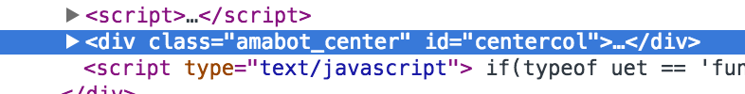

2. <a href inside of class="rankedItem"

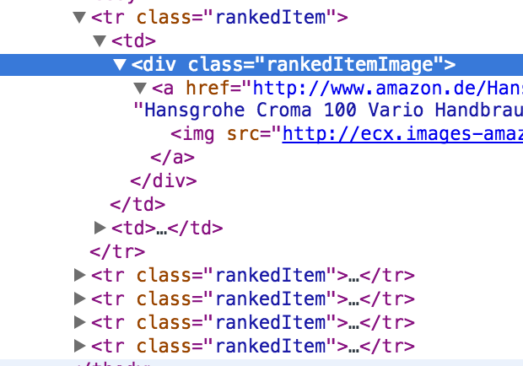1.